Lane College
Field Experience Handbook

Draft 1: Fall 2017-2018

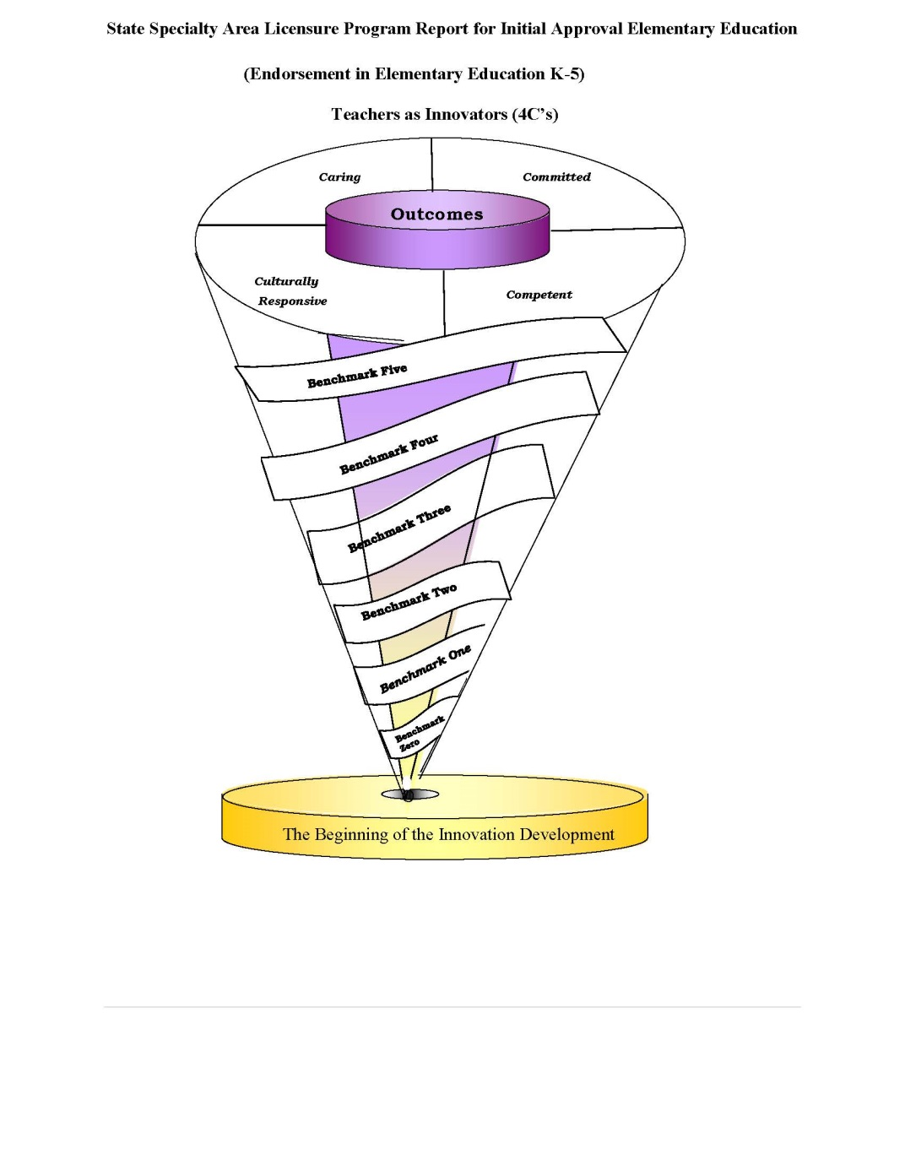
Department of Education

Table of Contents

Welcome to “Field Experience” 3
Mission Statement 4
Overarching Unit Goals 4
Conceptual Framework 5
Department of Education Learning Outcomes 6
Field Experience 8
Lane College Assessment System LCAS 10
General Roles and Responsibilities 11
Field Placement Policy 14
Field Experience Requirements 14
Key Assessments –C & I Initial 15
Field Experience Requirements 16
Admission into Clinical Practice 18
Time Frame for Clinical Teaching 19
The Professional Seminar 20
Removal Procedures from Field Experience 20
Forms 22
EDU232 Field Experience, Elementary, Field Log 23
CLASSROOM OBSERVATION/ FIELD EXPERIENCE FORM 24
Teacher Candidate Dispositions 27
Field Experience Evaluation Form 31

Welcome to “Field Experience”

Welcome to field experience component of the Educator Preparation program. Past graduates often describe this as an enjoyable and rewarding part of their education year. Cooperating/Mentor Teachers often report that the presence of our teacher candidates in their classroom adds to their own professional and personal enrichment.
At the Lane College Department of Education, we are proud of the long-standing and successful partnership between the Faculty of Education and our local schools. We, therefore, also extend a warm welcome to our Cooperating/Mentor Principals and Teachers. Your hard work and dedication to our program is vital for its ongoing success and is truly appreciated. We hope to offer as much support as possible, particularly to new Associates/Mentors. Please do not hesitate to direct any questions to the Field Experience Office or to any of the Faculty representatives in the course of their school visitations.
The Field Experience Handbook informs candidates, teachers, principals, faculty advisors and school board personnel about the expectations, policies and procedures that are designed to make this experience as effective and enjoyable as possible for all participants.

Best wishes for a successful and enjoyable year.

XXXXXXXXXXXX, Director

Mission Statement
The Department of Education is committed to the preparation of 21st century teachers who understand the complexities of learning and teaching which encompass inclusion, equity, and social justice. This work is enhanced by a liberal studies foundation that encourages breadth of knowledge, interdisciplinary and international perspectives, engaged inquiry, and intellectual curiosity. We strive to prepare teacher candidates to possess the 4 C’s; Caring, Committed, Culturally Responsive, Competent educators who possess a deep knowledge in their field of study and also work collaboratively to achieve high quality education for all.

The organizing theme of the Department of Education is “teachers as innovators”. We strive to help our candidates build and construct new methods, ideas and strategies for meeting the challenging and diverse needs of today’s students.

Overarching Unit Goals
Unit Operations Goals
- Meet state and national standards for the Unit.
- Ensure the excellence of all licensure programs in the Unit.
- Respond to the needs of the regional and state-wide teaching community.
Unit Program Goals
- Meet the state and national standards relevant to the various programs.
- Meet the Unit Goals for candidates through the various programs.
- Continue to build strong partnerships with stakeholders.
Unit Candidate Goals
- Candidates demonstrate knowledge of the depth, breadth, and interdisciplinary connections inherent in the specialty area discipline studied.
- Candidates are knowledgeable of subject matter in order to create meaningful learning experiences for all learners.
- Candidates develop skills necessary for self-reflection and use this reflection to support student learning and development.
- Candidates demonstrate professional dispositions in varied educational settings with regard to a diversity of students and all members of the school community

Conceptual Framework

Description of the Conceptual Framework
A graphic schema was constructed to incorporate the department of education’s Conceptual Framework. The six ribbons in the schema symbolize our benchmarks. Each benchmark provides information regarding how our teacher candidates matriculate through the program. The top of the spiral represents the expectations held by faculty that graduates will be caring, committed, competent and culturally responsive urban educators. The faculty uses the acronym 4C’s to refer to the spiral construction model.

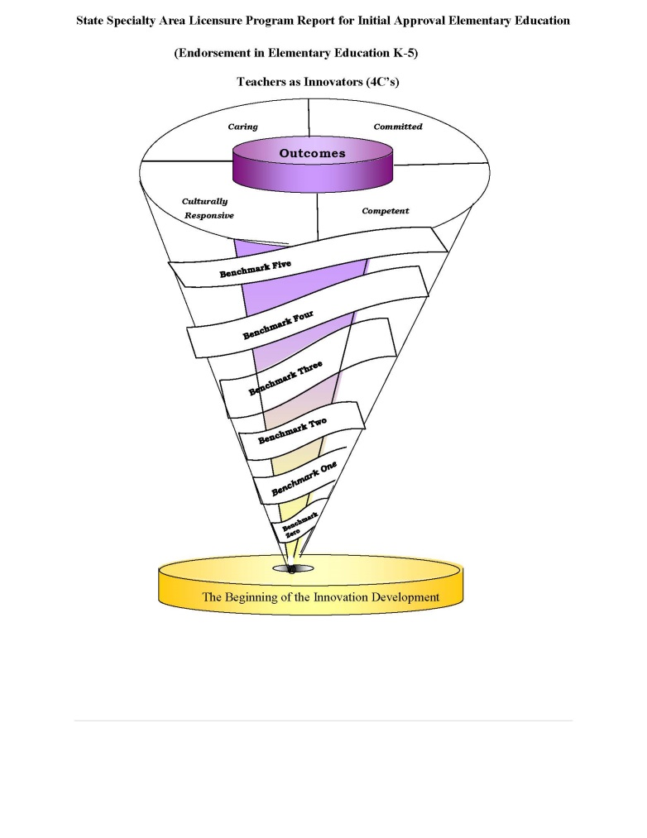

Department of Education Learning Outcomes
Initial Programs

Expected Outcomes
In developing the conceptual framework, the Conceptual Framework Committee identified four core outcomes that are significant to the development of a unique kind of professional who is specifically equipped to effectively serve urban populations. To this end, the DOE prepares caring, committed, competent, and culturally responsive professionals who will work effectively in all school settings, with a focus on the needs of urban communities. To assure that candidates meet these outcomes, the unit has developed a set of 21 proficiencies, which identify the knowledge, skills, and dispositions that candidates must show mastery upon exit from the programs. The proficiencies have been designed to ensure candidates meet the four unit-developed outcomes within the context of the state and national standards to which they are accountable.

Proficiencies are organized into three categories, with proficiencies for committed and culturally responsive educator combined in one category.
(K) Knowledge
(S) Skill

A List of Candidate Proficiencies
A competent educator:
  - demonstrates knowledge of the content that is being taught, and is able to assist students in the process of mastering content through the use of research-based practices; (K)
  - demonstrates the capacity to problem solve, and to think critically and reflectively; (K)
  - demonstrates an understanding of human development, and the ability to act on this understanding; (S)
  - demonstrates an understanding of classroom organization, planning, and management and the ability to act on this understanding; (S)
  - demonstrates an understanding of learning as a socially mediated, constructive process, and the ability to act on that understanding; (S)
  - demonstrates an understanding of effective communication and collaboration strategies; (K)
  - demonstrates an understanding of research, assessment and evaluation as ongoing processes involving multiple sources of information and techniques; (K)
  - demonstrates an understanding of the importance of involving families, communities, and colleagues in the education of all children, and the ability to act on this understanding; and (S)
  - demonstrates knowledge of current technology in educational practice, and the ability to apply it in a classroom or school setting. (S)

A committed and culturally responsive educator:
  - acts on the belief that all children can learn and creates instructional opportunities that adapt to learners from diverse cultural backgrounds and with exceptionalities; (K)
  - demonstrates an understanding of the urgency to accommodate the nature and needs of each learner, and is able to act on this understanding; (S)
  - demonstrates a commitment to high moral and ethical values; and (K)
  - assumes accountability for the outcomes of instruction, and continually validates the effects of his/her choices and actions on others. (S)
  - values and appreciates cultural differences within a classroom or school setting, and is able to apply an understanding of cultural and linguistic diversity to the design and implementation of instruction. (K)

A caring educator (dispositions)
  - understands the right of all students to have access to a curriculum that allows them to develop to their full potential, and is able to act as an advocate for students in this respect;
  - maintains confidentiality;
  - demonstrates appropriate behaviors during class settings and in the work environment. The candidate has been alert and responsive, consistently.
  - demonstrates respect for the profession;
  - demonstrates punctuality in arrival to class, practicum, student teaching, field experience meetings, etc.
  - demonstrates the ability to compromise and to respect others’ opinions during group work;
  - participates in professional development activities that were recommended.

Field Experience

The Lane College Department of Education faculty strives to offer a learning-centered program committed to excellence in teaching and learning. Field experience serves this goal by providing teacher candidates with opportunities to experience classroom observation and teaching in a variety of settings, apply and develop pedagogical knowledge and skills acquired through their faculty courses, and benefit from the advice and guidance of experienced professionals in their progress towards acceptance into the profession.
Field Experience takes place in content courses, Block 1, Clinical Teaching I and Clinical Teaching II of the Educator Preparation Program. Each experience will help prepare candidates to become classroom teachers. This phase of the program allows candidates an opportunity to learn theory and enter the teaching profession practicing the knowledge, skills, and attitudes about teaching and learning they have learned in class.
The candidate field experience is a valuable hands-on experience that represents the bridge between professional preparation and professional practice. Field experiences are designed to provide opportunities for candidate teachers to observe, plan, implement, and evaluate instructional materials and techniques in order to meet the varied learning needs of students from diverse cultures and backgrounds.
As such, candidate teachers in observation courses are expected to apply the techniques, strategies, and behaviors described in the standards for the Pedagogy and Professional Responsibilities exam. These experiences are an opportunity for candidate teachers to design lessons utilizing state standards and the competencies described in the areas of certification by the Tennessee Department of Education. A complete description of these standards and competencies may be obtained from the state website. Often candidate teachers observe that these learner-centered teaching behaviors are not utilized in the classes they attend in their teacher preparation courses, nor are they present in the classrooms they observe in their professional development courses. It is during this experience that candidate teachers are expected to become “teachers as researchers”. They have an opportunity to develop instructional designs that reflect both the content standards and competencies expected of their students in the state of Tennessee , as well as to display the knowledge, dispositions, and pedagogical behaviors of effective teachers as delineated by the standards and competencies assessed on the state certification tests.

Moreover, candidate teachers have an opportunity to “field-test” the behaviors of effective teachers cited in research journals, which are reported to have a positive impact on student achievement. This field experience also serves as an opportunity to engage in the behaviors described in the research on effective teachers, student achievement and teaching. The success of the candidate teaching observation depends on the cooperative efforts of many people. It is expected that the candidate teacher, supervising teacher, and the university professor will form a triad with closely connected goals-all resulting in a positive and memorable filed experience. It is the goal and expectation of the Department of Education’s Educator Preparation Program that all participants will become reflective professional practitioners who are committed to facilitating successful student achievement. The documentation of these experiences will be in the development of an electronic portfolio submitted by each candidate chronicling his/her experience.

Placement

The Office of the Field Experience and Clinical Practice Coordinator takes into account multiple factors in determining your placement. Many variables play a role in each placement to ensure your ability to complete field-based assignments and critical tasks. The most important factor is matching your field experience placement with your course(s) needs. For example, if you are taking an ESOL course you will be placed in a school that has a high percentage of ESOL students. Moreover, all students will be placed in multiple diverse settings and not placed at the same school twice.

- We strive to take every situation into account when making decisions about field placement. We try to place students that do not have a car at schools close to their homes, close to campus, and/or close to public transportation.
- We place cluster groups of students at the same school to encourage learning communities and carpooling.
- Some schools hold an orientation for field experience students. You will be advised via email of the date and time of the orientation, and attendance is mandatory. If you have a conflict with your class schedule you are advised to consult with your course instructor.
- You will be allowed to participate in orientation before the fingerprinting process is completed. However, you will NOT be able to report to a classroom until your fingerprints have been cleared and you have received your clearance.
- When you report to the school’s main office, identify yourself, and ask to meet with the field experience contact person and/or an assistant principal. If neither is available, please ask to report to the classroom of your assigned teacher.

Final notes on placement

- Schools are notified via e-mail with a list of names of students who will be completing field experiences.
- Return the Field Experience Contract, the Field Experience Student Attendance Record, and the Field Experience Evaluation Report to the Office.
- The Field Experience Contract should be turned in within the first two weeks of beginning your field experience.
- Please remember that you are a guest at each school site and represent Lane College and the Department of Education.
- Field Experience Placements should begin as soon as you have your Security Clearance Card. If you wait until the middle of the semester, the school has the prerogative to deny you access to the school.

Issues with placements
- Placements are final. Only under exceptional circumstances will a change of placement be considered. Please make your request via e-mail to the Director of Field Experience and Clinical Practice.
- Please note, if you have not made any attempt to visit your field experience placement by the last day to drop a class with a “W”, any request to change your placement will not be considered.
- Receive your Field Experience Placement by the second week of classes
- Begin your Field Experience Hours by the third week of classes
- Request to change a placement need to be made by the last day to drop a class with a “W”.

Lane College Assessment System LCAS

The Department of Education at Lane College, through research, has identified key assessments, which demonstrate that candidates have met the 21 proficiencies that describe the outcomes of the Conceptual Framework (CF), and they are prepared to graduate from the Unit’s programs. LCAS utilizes a multifaceted assessment system linking the performance of Unit candidates to the Unit’s conceptual framework, national and professional standards, appropriate Specific Professional Association (SPA) standards, and PK-12 student learning
The assessment system has two functions. The first function is to monitor the progress of individual candidates through programs, as defined by the requirements at each transition point in a candidate’s program. This function makes it possible to ensure that all candidates meet the requirements that are expected of them before moving to the next stage of their program, and also ensures that all candidates can be efficiently and effectively advised of their progress and standing in their program.
A second function of the assessment system is to monitor overall Unit operations regarding effectiveness of programs. This involves monitoring and creating “feedback loops” for the review of assessment data, employer and graduate survey data, faculty resources, productivity and results of national and state program reviews. Reports, based on the compilation of data stored in the system, are developed by the Assessment Coordinator with support from the Office of Institutional Effectiveness and the Department of Education/Teacher Certification Office (The data is derived from the State Board for Educator Certification). Reports are analyzed by program faculty, members of the Assessment Committee, the Teacher Education Council (TEC), and the Leadership Team.

The assessment system is provided at no cost for the Teacher Candidates. Your field experience instructor will provide the teacher candidates with the log-in information and how to access forms for the course online.

General Roles and Responsibilities

Teacher Candidates’ success in practice teaching requires assuming responsibility for professional growth. This involves attention to four main areas: Attitude, Orientation, Observation, and Participation.
Professional attitude involves:
- recognition and acceptance that the welfare of the students is of ultimate concern and that the cooperating teacher has the final responsibility for what occurs in the classroom;
- maintenance of an ethical and professional attitude towards all members of the school community;
- adhere to the Code of Ethics and Standard Practices for Tennessee Educators
- continuous evaluation of one’s growth as a teacher;
- ability to accept critical suggestions and assessments in a cooperative and positive manner.
Orientation involves:
- familiarizing oneself with the philosophy, resources, policies, and rules of the school assigned;
- conferring with the cooperating teacher prior to the beginning of each practicum.
Observation includes:
- determining the procedures to be followed in completing assignments which are acceptable to the cooperating teacher;
- observing in a systematic and purposeful manner, remembering that the observation is designed for one’s introduction to the educator’s role;
- arranging opportunities, through the cooperating teacher, to observe other classrooms and teachers in order to broaden one’s perspective of the teaching role.
Participation includes:
- increasingly assuming responsibility for more complex tasks;
- making oneself available for regular conferences (planning and analysis) with the cooperating teacher or Department Supervisor;
- developing written plans for lessons and making them available to all supervisory personnel;
- participating in school activities beyond the classroom setting;
- engaging in critical self-reflection regarding teaching and professional conduct;
- attending all advisory group meetings
Cooperating Teachers serve as mentors and coaches to teacher candidates by providing modelling, guidance and support in a number of varied and integrated areas.
Orientation and Observation Mentoring in this phase includes:
- welcoming the teacher candidate to the school and the classroom;
- familiarizing the teacher candidate with the school’s expectations;
- orienting the teacher candidate to the school, which includes providing information about the programs, the students and the school/classroom, routines and procedures;
- providing the teacher candidate with adequate opportunities to observe the cooperating teacher’s own teaching techniques and procedures and, where possible, those of other teachers in the school.

Teaching Practice Mentoring includes:
- enabling teacher candidates to progress from simpler to more complex teaching tasks;
- providing the teacher candidate with opportunities to co-teach and co-plan, moving teacher candidates gradually towards greater responsibility as appropriate;
- assisting teacher candidates in planning their own teaching strategies and in selecting and designing appropriate instructional material; guiding teacher candidates in developing sound classroom organization and management strategies;
- requiring the teacher candidate to prepare and submit detailed written lesson plans for each lesson and unit plans where appropriate;
- requiring the teacher candidate to prepare thoughtful written self-reflection for each lesson;
- preparing Formative and Summative Assessments that are fair and appropriately rigorous.
- 5 formal teaching lesson evaluations (3 first placement- two second placement)
- Disposition rubric (one completed at each placement)
- Perception Student Impact (one completed at each placement)
- Attendance Log signed daily

Providing consistent feedback to teacher candidates is important to their growth and development as teachers and professionals. Here are a few tips that might help you in providing quality feedback to candidates.
- Remember that, like the students in your class, teacher candidates will vary in their readiness to independently perform certain teaching tasks.
- Some teacher candidates will require more assistance, guidance and encouragement than others.
- Make your expectations clear from the onset.
- Ensure that the teacher candidate(s) in your classroom take notes during observation
- Set aside a few minutes each day to discuss their notes and progress.
- Always provide feedback on strengths and strategies for improvement.
- Feedback should be realistic, honest and fair. Teacher candidates should be mature enough to handle constructive criticism even when it sometimes stings
- Regular conferences allow the teacher candidate to analyze their own instructional skills and to set goals and strategies for improvement.
Things to Remember
- Contact the Department Supervisor as soon as possible if a teacher candidate is experiencing difficulties in your class.
- Teacher candidates should not be left alone with students under any circumstances.
Department Supervisor is expected to:
- maintain regular contact with their advisees throughout the year;
- visit advisees in the schools at least twice, but as much as deemed necessary;
- meet with them regularly, individually or in group seminars to discuss issues relating to the practicum experience before and after each teaching block;
- provide a minimum of two (2) Formative Reports (see Appendix E) during the Practice
Teaching sessions;
- at the request of the Field Experience Office, investigate reports from schools of individual problems;
- mediate candidate-teacher conflicts;
- act as a liaison between the school and the Faculty of Education;
- collect and review copies of the Formative and Summative Report for each placement.
- reviewing these reports allows for Advisors to address common issues or concerns;
- complete Portfolio review with each teacher candidate in their Advisory Group;
- complete final summative Report/Portfolio Assessment of each teacher candidate;
- assisting in the orientation of teacher candidates assigned to their school;
- facilitate teacher candidate’s involvement in activities beyond the classroom setting (e.g., staff meetings, staff socials, student functions, professional development days, parent/teacher conferences);
- cooperate with Faculty Advisors in solving problems that may arise;
- provide both positive and critical feedback to the Field Experience Office on the general performance of teacher candidates and the administration of the practicum.

Field Placement Policy

In the interest of fairness and consistency, the following policy for practice teaching is applied equally and without exception to all teacher candidates. Classroom placements are arranged with the following school districts in which MoU agreements are placed.

- Candidates may not be involved in arranging their own placements.
- Candidates may not make requests for their practicum placements.
- All arrangements are made by and through the Field Experience Office.
- Requests for changes of placement cannot be considered for reasons of convenience or transportation.
- Placements are not permitted with a cooperating teacher who is related to or a close friend of the candidate, or in a school attended by the candidate’s children.
- Practicum situations involving possible conflicts of interest should be brought to the attention of the Field Experience Office before placement.

Field Experience Requirements
Field Experience is incorporated in several classes.
- Each content class requires 8 hours of observation.
- Field Experience Courses: EDU 230, EDU 232, EDU 334, EDU 333, EDU 337, and EDU 338

Assessments

Key Assessments –C & I Initial

PROFESSIONAL CORE | Hours | Assessments
EDU 230 Foundations of Education (FE) | 3 |  | - Disposition Instrument  - Perception Instrument  - Community Observation Form  - Reflective Journal
EDU 232 Elementary Curriculum & Instruction (FE) | 3 |  | - Disposition Instrument  - Perception Instrument  - Six Level Unit Plan with Adaptations & Modifications
EDU 334 Teaching Elementary Science (FE) | 3 |  | - Disposition Instrument  - Perception Instrument  - The Science Circus (collaborative)  - Science Lesson Plan
EDU 333 Teaching Elementary Social Studies (FE) | 2 |  | - Deposition Instrument  - Perception Instrument  - Lesson Plans- Teaching a Social Studies Reading Strategy Using Modeling and Guided Practice  - Constructing Knowledge Through Social Studies Unit Project  - Public Issues Exploration Lesson: Plan, Enactment, & Analysis
EDU 337 Teaching Elementary Mathematics (FE) | 3 |  | - Disposition Instrument  - Perception Instrument  - Lesson Plans  - Lesson Study Group Presentations & Participation Assignments  - Individual Student Assessment -Performance Based Assessment for the Course
EDU 338 Reading and Writing (FE) | 3 |  | - Disposition Instrument  - Perception Instrument  - Lesson Plans

ENHANCED STUDENT TEACHING Assessments
EDU 420 Student Teaching Seminar | 3 | - Disposition Instrument  - Perception Instrument  - Lesson Plans  - ePortfolio  - Teacher Work Sample (TWS)  - Action Research and Presentation  - Reflective Journal
EDU 430 Enhanced Student Teaching | 9

Field Experience Requirements
Goals for Content Courses Field Experience
- Complete ten hours of field experience at a designated school site.
- Observe and reflect on specific content classroom instruction.
- Design and deliver specific content instruction that meets the needs of diverse learners.
- Develop and utilize methods of evaluations for specific content.
- Use effective classroom management strategies in specific content classes.

Activities within the Content Courses Field Experience may include, but are not limited to:
- Classroom Observations
  - Observing a variety of teaching and learning situations.
- Classroom Instructional Support
  - Assist with logistical classroom routines
  - Preparing instructional materials
  - Prepare and manage the physical or online environment.
  - Assess student papers, exams, quizzes.
  - Provide students with appropriate feedback, praise, and positive reinforcement.
  - Facilitating/chaperoning field trips.
  - Investigating research associated with appropriate teaching and learning strategies.
- Classroom Instruction
  - Delivering short presentations to students.
  - Facilitating small group work in class, library, or other settings.
  - Supervising groups during learning centers.
  - Tutoring individual or small groups of students.
  - Team teaching with cooperating teacher or peer.
  - Teaching and managing a classroom.
  - Creating implementing lesson plans and assessment strategies associated with classroom instruction.
- Professional Interactions
  - Attending extracurricular or co-curricular events.
  - Attending professional meetings.
  - Attending parent-teacher meetings.

Goals for EDU 230 Field Experience
- Complete twenty hours of field experience at a designated school site.
- Observe and reflect on classroom instruction.
- Observe the delivery of design and deliver instruction that meets the needs of diverse learners.
- Observe the delivery of develop and utilize methods of evaluations.
- Observe effective classroom management strategies.

Activities within the Field Experience may include, but are not limited to:
- Classroom Observations
  - Observing a variety of teaching and learning situations.
- Classroom Instructional Support
  - Assist with logistical classroom routines
  - Preparing instructional materials
  - Prepare and manage the physical or online environment.
  - Investigating research associated with appropriate teaching and learning strategies.
- Classroom Instruction
  - Delivering short presentations to students.
  - Facilitating small group work in class, library, or other settings.
  - Supervising groups during learning centers.
  - Tutoring individual or small groups of students.
- Professional Interactions
  - Attend extracurricular or co-curricular events.
  - Attend professional meetings.
  - Attend parent-teacher meetings.

Goals for Candidate Teachers in Content Courses: EDU 232, EDU 334, EDU 333, EDU 337, and EDU 338
- Complete 8 to 12 hours of field experience at a designated school site.
- Observe and reflect on classroom instruction.
- Design and deliver instruction that meets the needs of diverse learners.
- Develop and utilize methods of evaluations.
- Deliver effective classroom management strategies.
- Deliver small group lessons utilizing learned methodology from cooperating teacher and university faculty.
- Deliver whole group lessons utilizing learned methodology from cooperating teacher and university faculty.

Activities within the Field Experience may include, but are not limited to:
- Classroom Observations
  - Observing a variety of teaching and learning situations.
- Classroom Instructional Support
  - Assist with logistical classroom routines
  - Preparing instructional materials
  - Prepare and manage the physical or online environment.
  - Assess student papers, exams, quizzes.
  - Provide students with appropriate feedback, praise, and positive reinforcement.
  - Facilitating/chaperoning field trips.
  - Investigating research associated with appropriate teaching and learning strategies.
- Classroom Instruction
  - Delivering short presentations to students.
  - Facilitating small group work in class, library, or other settings.
  - Supervising groups during learning centers.
  - Tutoring individual or small groups of students.
  - Team teaching with cooperating teacher.
  - Teach independent of cooperating teacher.
- Professional Interactions
  - Attend extracurricular or co-curricular events.
  - Attend professional meetings.
  - Attend parent-teacher meetings.

Admission into Clinical Practice

Admission into Clinical Practice is the third benchmark. At this stage, candidates are required to demonstrate their mastery of the 21 proficiencies. Candidates at this benchmark are assigned to a school for one semester. Candidates are required at the school to engage in a range of activities including actual teaching of lessons, developing lesson plans and observing parent-teacher conferences. Each candidate is evaluated across several assessments listed in the Key Assessment Chart. Candidate success at this benchmark is determined by three independent evaluators, a School Based Representative, Department of Education Faculty Advisor, and a representative from the Office of Field Based Experiences.

Goals for Candidate Teachers Enhanced Teaching: EDU 420 ad EDU 430

- Complete fifteen (15) weeks of field experience at a designated school site- four days per week and one seminar day.
- Observe and reflect on classroom instruction.
- Design and deliver instruction that meets the needs of diverse learners.
- Develop and utilize methods of evaluations.
- Deliver effective classroom management strategies.
- Deliver small group lessons utilizing learned methodology from cooperating teacher and university faculty.
- Deliver whole group lessons utilizing learned methodology from cooperating teacher and university faculty.

Activities within the Field Experience may include, but are not limited to:
- Classroom Observations
  - Observing a variety of teaching and learning situations.
- Classroom Instructional Support
  - Assist with logistical classroom routines
  - Preparing instructional materials
  - Prepare and manage the physical or online environment.
  - Assess student papers, exams, quizzes.
  - Provide students with appropriate feedback, praise, and positive reinforcement.
  - Facilitating/chaperoning field trips.
  - Investigating research associated with appropriate teaching and learning strategies.
  - Complete Action Research Plan and Teacher Work Sample. (See Clinical Handbook}
- Classroom Instruction
  - Delivering complete presentations to students.
  - Facilitating small group work in class, library, or other settings.
  - Supervising groups during learning centers.
  - Tutoring individual or small groups of students.
  - Team teaching with cooperating teacher.
  - Teach independent of cooperating teacher.
  - Manage classroom environment independent of the cooperating teacher
- Professional Interactions
  - Attend extracurricular or co-curricular events.
  - Attend professional meetings.
  - Attend parent-teacher meetings.

Time Frame for Clinical Teaching
- Week 1- The clinical teacher should observe, assist, and team teach. The majority of time should be focused on learning classroom routines and materials and on observing students and mentor teachers. The clinical teacher should assume responsibility for small group work or one-on-one tutoring with students.

- Week 2 or before- The clinical teacher should be ready to co-plan and teach 1-3 subjects or class periods per day.

- Week 3- The clinical teacher should be gradually transitioning from mentor teacher to clinical teacher during this time period. The clinical teacher should be teaching at least half-time and should move to full-time teaching by the end of the week.

- Week 4 – Week 6 /7- The clinical teacher should assume all classroom responsibilities under the direction of their mentor teacher. Responsibilities include planning with the teacher, preparation and teaching of all subjects, student evaluation and any other duties assigned by the mentor teacher.

- Week 7 or 8-The final week of clinical teaching should be a time of transition as the mentor teacher resumes total teaching responsibility.

The Professional Seminar
There are many facets of clinical teaching providing knowledge and direction for students. There are specific topics for which you need to be prepared. Previous clinical teachers have assisted us in identifying some of the important issues we need to address during the student teaching semester. In an effort to better prepare our students for their “professional semester,” students will be required to participate in the seminars such as the following:

▪ Professionalism and Ethics in the Workplace
▪ Legal Concerns in the Educational Setting
▪ Professional Development Appraisal System
▪ Parents and Parent Conferencing
▪ Classroom Management
▪ Getting Organized
▪ First Days of School
▪ Job Interviews

The scheduled seminars will be included on the clinical teaching calendar and will also allow students time to share with each other and with the Director of Field Experiences. The seminars will be held on different days and times. Please refer to the calendar for dates and times. The seminars are mandatory.

Removal Procedures from Field Experience

The College reserves the right to remove a clinical teacher from clinical teaching in the event that the College and/or the mentor or school district feels it is necessary. In the even that a student must be dropped from field experience/clinical teaching, the following steps will be taken:
- Automatic removal can take place if the clinical teacher places any student at risk and/or commits any act that the Department and/or the school district believe is detrimental to the welfare of any student.

- In some cases, prior to removal from the clinical teaching semester, the student will be counseled on weaknesses and given the opportunity to improve.

- If the teacher candidate has been counseled and has shown no improvement, the college reserves the right to meet with the mentor teacher, student, principal, and/or representatives from the College. The College/Department representatives will include the Director of Field Experiences, Filed Experience/ Clinical Teaching Committee, and any others the administrators in the Department of Education deem necessary.

In the event that all agree, there will be a written, signed agreement with signatures from the Director of Field Experiences and Field Experience/Clinical Teaching Committee indicating the need for the student removal from the classroom. It is not our intention to remove a student from the clinical teaching semester. This would be done as a last resort and in thorough agreement with the parties mentioned above. It is our hope that all clinical teachers will complete their semester with a positive experience. If any of the above should occur, the student will be dropped from the clinical teaching semester.

Forms

EDU232 Field Experience, Elementary, Field Log
Classroom Observation/ Field Experience Form
Disposition Form
Field Experience Evaluation Form

EDU232 Field Experience, Elementary, Field Log

EDU 232, Field Experience, Elementary, requires teacher candidates to observe and participate in an elementary classroom with a mentor teacher and their students for two days a week, from 7:30 am – 2:30 pm or 7:45 am – 2:45 pm throughout Semesters 1, 2, and 3 in our program. The mentor teacher needs to initial the candidate’s field log each time the candidate is in their classroom. Teacher candidates place this log in their field binder and make this document accessible to field supervisors for review. At the end of the semester, this form is given to the field supervisor. Candidates make a copy of this form to include in the professional teaching portfolio.

Your name: ___________________________ Mentor Teacher: ________________________________________

School: _____________________________________________ Grade ________ Semester __________________

DATE | TIME (from/to) | Total of Hrs | Mentor’s Signature or Initials

University Supervisor’s Sign Off: ____________________________ Date: _____________

CLASSROOM OBSERVATION/ FIELD EXPERIENCE FORM

Student Name: ______________________________________ Date: _____________________

Grade Level: Early Childhood Pre-K Elementary K-5
Middle School 6-8 Secondary 9-12

Content Area Art Education Career Education/Work
Computer Technology English
Family/Consumer Science Health/Safety Education
Library/Media Mathematics
Music Education Physical Education
Reading/Language Arts Science
Social Studies/History Technology Education
World Languages
Content Level: General Education Special Education
Advanced Placement Honors/Scholars Other
Location: School District
Public Private Charter Urban Suburban Rural

School Building or Observation Site_________________________________________
Principal’s Name________________________________________________________
School Address_________________________________________________________
City___________________________________ State _______ Zip Code___________
School Telephone Number ________________________________________________
Name of Teacher _______________________________________________________
Specific Content Area _____________________________ Grade Level ____________
Verification:
I verify that the above named student from Lane College observed and/or conducted field experience in the above named location and classroom on Date ______for a total number
of hours at 60 minutes per hour.

Name Title __________
Signature_______________________________________________ Date
If no alternate assignment is required as part of a course requirement, the observer must respond to each of the statements below with a full and complete reflection on what transpired in the classroom. All observations must be typed on this form.

Reflective Log
DOMAIN I: CLASSROOM ENVIRONMENT
Observe, reflect and respond to the following Components of the classroom environment:

1. Creating an environment of respect and rapport: Describe the teacher’s interaction with students and students’ interactions among one another.

2. Establishing a culture for learning: Describe the importance of the content being taught, the ways students demonstrate pride in their work and the teacher’s expectations for learning and achievement.

3. Managing classroom procedures: Describe how the teacher manages instructional groups, makes transitions between activities and lesson, distributes materials and supplies, performs non-instructional duties and supervises volunteers and paraprofessionals.

4. Managing student behavior: Describe how the teacher conveys expectations, monitors student behavior and responds to student misbehavior.

5. Organizing physical space: Describe the classroom in terms of safety and arrangement of furniture and accessibility to learning and the use of physical resources.

DOMAIN I: CLASSROOM INSTRUCTION AND COMMUNICATION
Observe, reflect and respond to the following Components of classroom instruction and communication:

1. Communicating clearly and accurately: Describe how the teacher provides directions, establishes and maintains procedures and uses oral and written language.

2. Using questioning and discussion techniques: Describe the quality of questions posed, the discussion techniques used and the quality and quantity of student participation.

3. Engaging students in learning: Describe how the teacher represents the content, facilitates activities and assignments, groups’ students, uses various instructional materials and resources, structures and paces the lessons.

4. Providing feedback to students: Describe the quality and timeliness of teacher feedback to students in terms of accuracy, substance, constructiveness and specificity.

5. Demonstrating flexibility and responsiveness: Describe how the teacher adjusts lessons, responds to students and shows persistence.

Lane College
Department of Education

Teacher Candidate Dispositions
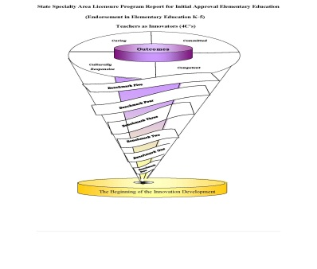
Directions for completing evaluation form:

Candidate teachers:

Conclude whether or not candidate teachers are struggling, emerging or on-target with the dispositional behaviors.
- Mark the appropriate column. Compare your growth each time you complete a self-assessment.
- Provide two copies of the completed document for review by course instructor.
- If your self-assessment differs from faculty assessment, you may be asked to meet with the instructor.
- Both parties will sign the documents. The instructor will deliver one copy to the Office of Field Experience and Clinical Practice. The other copy is retained by the candidate.

College faculty/ Clinical Practice supervisor

- Complete the evaluation form at the start and end of core courses as provided on the 2nd page.
- Complete the evaluation form at the end of clinical practice.
- Share the information on the form with the candidate teacher.
- Sign and date the form and have the candidate teacher also sign your form.

Mentor Teacher

- Complete the form at the end of the clinical practice placement in your class.
- Share the information on the form with the candidate teacher.
- Sign and date the form and have the candidate teacher also sign your form.

What are dispositions? The habits of professional action and moral commitments that underlie an educator’s performance (InTASC Model Core Teaching Standards, p. 6-CAEP). The Department of Education dispositions are aligned to CAEP and InTASC as well as the Department’s Conceptual Framework. All teacher candidates will be reviewed for dispositional growth and development.

Who does the assessment? Each candidate will complete a self-assessment. The course instructor and/or field mentor teacher will each complete a separate assessment of the candidate. The candidate and instructor may discuss observations of behavior in coursework, field work, and the candidate identified disposition development goals.

When and where is a candidate assessed? Each candidate will be reviewed for dispositional growth and development throughout their participation in the EPP. Formal documentation of assessments will occur a minimum of four times. The table below shows the course number in which a documented assessment will occur. Faculty may choose to use the assessment at other appropriate times.

Initial Program
Elementary K-5
B(0) | B(1) | B(2) | B(3) | B(4) | B(4) | Where do I Submit
Entry into College | Admission | Field Experience | Clinical Practices  Before Admission  During Course  After Course | Completion of program | Follow-up
N/A | Admission’s Application  EDU 230 | EDU 232  EDU 334  EDU 333  EDU 337  EDU 338 | EDU 420  EDU430 | N/A | N/A | Instructor, Portfolio, LCAS System

* The table also shows where the signed assessment form should go when completed. Once signed, keep a copy for on-going reflection throughout your program. Each semester, in addition to the course-based assessment, the Disposition Committee will review all completed assessments to determine whether there has been growth demonstrated over time. Any concerns will be addressed by this committee.

What else should a teacher candidate know? It is the candidate’s responsibility to ask clarifying questions as well as demonstrate the expected dispositional behaviors. REMEMBER: Only those dispositions observed in the college classroom or field practicum can be measured, therefore it is up to the candidate to demonstrate these dispositions in all settings.

The Disposition of CARING…

Candidate Name ____________________________________

… involves caring about and caring for. It is caring about others that moves an individual toward caring for others. When a teacher candidate cares about education and access for all, the candidate is moved to stand in solidarity with, and thus care for others. Care is viewed as a matter of relationships among diverse people (e.g., ability, age, ethnicity, gender, language, sexuality, socio-economic status) rather than as an inherent virtue of an individual.
 | Struggling |  |  | Emerging |  |  | On-Target
understands the rights of all students and acts on the belief that all child can learn.  Instructor/Field Supervisor Comments:  Candidate Comments: | B 1 | B 2 | B3 | B1 | B 2 | B3 | B1 | B 2 | B 3
demonstrates Fa appropriate behaviors during class settings and in work environment; The candidate has been alert and responsive.
Instructor/Field Supervisor Comments:

Candidate Comments:
demonstrates a respect for the profession.
Instructor/Field Supervisor Comments:

Candidate Comments:
demonstrates punctuality with regard to arrival to class, practicum, student teaching, field experience, meetings and etc
Instructor/Field Supervisor Comments:

Candidate Comments:
maintains confidentiality
Instructor/Field Supervisor Comments:

Candidate Comments:
demonstrates the ability to compromise and to respect others’ opinions during group work
Instructor/Field Supervisor Comments:

Candidate Comments:
participates in professional development activities that were recommended.
Instructor/Field Supervisor Comments:

Candidate Comments:
_______________ _______ ______________________________ _______
Candidate’s Signature Date Instructor/Field Supervisor’s Signature Date

_______________________________________ _________________________________________ _________
Instructor printed name Signature Date

Field Experience Evaluation Form

(Semester, Year)
Course Instructor
Name of Placement/Field Work School:

Please answer the following questions by circling the number of the response that is best in line with your field experience. Additional comments are welcomed and encouraged.

5= Strongly Agree 4= Agree 3= Neutral

2= Disagree 1= Strongly Disagree

- The purpose and focus of the field experience were clearly understood. | 5 | 4 | 3 | 2 | 1
- Methods of evaluation were clearly communicated to me by the instructor. | 5 | 4 | 3 | 2 | 1
- The field experience was a valuable part of this course. | 5 | 4 | 3 | 2 | 1
- I was able to apply information learned in class for this field experience. | 5 | 4 | 3 | 2 | 1
- I had no difficulty getting into classrooms to complete my field experience. | 5 | 4 | 3 | 2 | 1
- I was well-received by faculty and staff of the school in which I worked. | 5 | 4 | 3 | 2 | 1
- I had good cooperation from the teachers with whom I worked. | 5 | 4 | 3 | 2 | 1
- I was able to participate in tutoring or assisting in the manner that I anticipated | 5 | 4 | 3 | 2 | 1
- The climate of the school in which I was placed was favorable. | 5 | 4 | 3 | 2 | 1
- I would recommend this school to other students. | 5 | 4 | 3 | 2 | 1

Additional Comments (Use Back, If Necessary): (*Note: For 1’s or 2’s, please explain the problems or difficulties you encountered.

