**Agenda**

July 12, 2018

Program Reestablishment

Elementary K-5

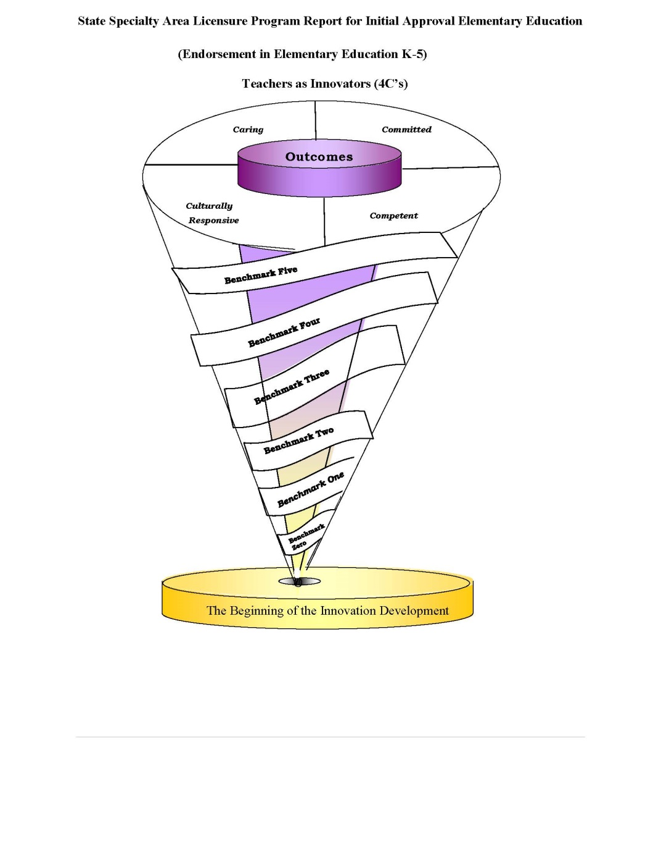

**9:00am – 10:00am**

Welcome/Introductions Dr. Coleman, Department Chair

President Report Dr. Logan Hampton, President

Program Support

Budget

Facilities

Overview of Program Dr. C. Waller, Director

Overview of the Teacher Education Council (TEC)

P-16 Advisory Board Structure Dr. D. Coleman, Department Chair

Unit Assessment Structure and Benchmarks Dr. C. Waller/Dr. Davis-Gonzales

Assessment System Mr. Jones C. Mays

LCAS

**10:00am- 12:00am**

Review report and address concerns

**Evidence:** TEC Constitution, P-16 Advisory Board Charge, Conceptual Framework (4 C’s- Teachers as Innovators), Field Experience Handbook, Disposition Handbook, Disposition Instrument, Unit Benchmarks, Assessment Handbook, K-5 Degree Plan, Unit Perception Instrument, Key Assessments for some content courses, and course outline development for new courses.

**Review of the State Report and Policy- addressing the concerns of the reviewers**

1. **State Standards-** After speaking to Dr. Bivens, Tennessee does not have state standards. Tennessee is using CAEP and national standards. Lane department of education will need to revise the report to only address CAEP, INTASC and SPA standards.
2. **DOE Unit Outcomes-** The Unit has 4 outcomes- Caring, Committee, Competent and Cultural Responsive- each outcome has proficiencies or indicators that the Unit/EPP will assess of teacher candidates.

**Department of Education Learning Outcomes (21 Proficiencies for the program)**

**Expected Outcomes**

In developing the conceptual framework, the Conceptual Framework Committee identified four core outcomes that are significant to the development of a unique kind of professional who is specifically equipped to effectively serve urban populations. To this end, the DOE prepares *caring, committed, competent, and culturally responsive* professionals who will work effectively in all school settings, with a focus on the needs of *urban* communities. To assure that candidates meet these outcomes, the unit has developed a set of 21 proficiencies, which identify the knowledge, skills, and dispositions that candidates must show mastery upon exit from the programs. The proficiencies have been designed to ensure candidates meet the four unit-developed outcomes within the context of the state and national standards to which they are accountable.

Proficiencies are organized into three categories, with proficiencies for committed and culturally responsive educator combined in one category.

(K) Knowledge

(S) Skill

**A List of Candidate Proficiencies**

**A competent educator:**

* 1. demonstrates knowledge of the content that is being taught, and is able to assist students in the process of mastering content through the use of research-based practices; **(K)**
  2. demonstrates the capacity to problem solve, and to think critically and reflectively; **(K)**
  3. demonstrates an understanding of human development, and the ability to act on this understanding; **(S)**
  4. demonstrates an understanding of classroom organization, planning, and management and the ability to act on this understanding; **(S)**
  5. demonstrates an understanding of learning as a socially mediated, constructive process, and the ability to act on that understanding; **(S)**
  6. demonstrates an understanding of effective communication and collaboration strategies; **(K)**
  7. demonstrates an understanding of research, assessment and evaluation as ongoing processes involving multiple sources of information and techniques; **(K)**
  8. demonstrates an understanding of the importance of involving families, communities, and colleagues in the education of all children, and the ability to act on this understanding; and **(S)**
  9. demonstrates knowledge of current technology in educational practice, and the ability to apply it in a classroom or school setting. **(S)**

**A committed and culturally responsive educator:**

* 1. acts on the belief that *all* children can learn and creates instructional opportunities that adapt to learners from diverse cultural backgrounds and with exceptionalities; (K)
  2. demonstrates an understanding of the urgency to accommodate the nature and needs of each learner, and is able to act on this understanding; **(S)**
  3. demonstrates a commitment to high moral and ethical values; and **(K)**
  4. assumes accountability for the outcomes of instruction, and continually validates the effects of his/her choices and actions on others. **(S)**
  5. values and appreciates cultural differences within a classroom or school setting, and is able to apply an understanding of cultural and linguistic diversity to the design and implementation of instruction. **(K)**

**A caring educator (dispositions)**

* 1. understands the right of *all* students to have access to a curriculum that allows them to develop to their full potential, and is able to act as an advocate for students in this respect;
  2. maintains confidentiality;
  3. demonstrates appropriate behaviors during class settings and in the work environment. The candidate has been alert and responsive, consistently.
  4. demonstrates respect for the profession;
  5. demonstrates punctuality in arrival to class, practicum, student teaching, field experience meetings, etc.
  6. demonstrates the ability to compromise and to respect others’ opinions during group work;
  7. participates in professional development activities that were recommended.

Print Your Name: ______________________ Teacher Candidate  Faculty Supervisor Your Student Number _____________

Department: _______________________________ Certification area:_______________ Date:___________

Indicate your status by **circling** one of the following options: Sophomore Junior Senior

Candidate Perceptions Regarding the Attainment of the Unit’s Knowledge, Skills and Dispositions

|  |  |  |  |  |  |  |
| --- | --- | --- | --- | --- | --- | --- |
| During my course work I demonstrated: | K Knowledge  S Skills | 1  Strongly  disagree | 2  Disagree | 3  No Opinion | 4  Agree | 5  Strongly Agree |
| **ACompetent educator:**  1.demonstrates knowledge of the content that is being taught, and is able to assist students in the process of mastering content through the use of research-based practices; | K |  |  |  |  |  |
| 2. demonstrates the capacity to problem solve, and to think critically and reflectively; | K |  |  |  |  |  |
| 3. demonstrates an understanding of human development, and the ability to act on this understanding; | S |  |  |  |  |  |
| 4. demonstrates an understanding of classroom organization, planning, and management and the ability to act on this understanding; | S |  |  |  |  |  |
| 5. demonstrates an understanding of learning as a socially mediated, constructive process, and the ability to act on that understanding; | S |  |  |  |  |  |
| 6. demonstrates an understanding of effective communication and collaboration strategies; | K |  |  |  |  |  |
| 7. demonstrates an understanding of research, assessment and evaluation as ongoing processes involving multiple sources of information and techniques; | K |  |  |  |  |  |
| 8. demonstrates an understanding of the importance of involving families, communities, and colleagues in the education of all children, and the ability to act on this understanding; and | S |  |  |  |  |  |
| 9. demonstrates knowledge of current technology in educational practice, and the ability to apply it in a classroom or school setting. | S |  |  |  |  |  |
| **A Committed and Culturally Responsive educator:**  10. acts on the belief that *all* children can learn and creates instructional opportunities that adapt to learners from diverse cultural backgrounds and with exceptionalities; | K |  |  |  |  |  |
| 11. demonstrates an understanding of the urgency to accommodate the nature and needs of each learner, and is able to act on this understanding; | S |  |  |  |  |  |
| 12. demonstrates a commitment to high moral and ethical values; and | K |  |  |  |  |  |
| 13. assumes accountability for the outcomes of instruction, and continually validates the effects of his/her choices and actions on others. | S |  |  |  |  |  |
| 14. values and appreciates cultural differences within a classroom or school setting, and is able to apply an understanding of cultural and linguistic diversity to the design and implementation of instruction. | K |  |  |  |  |  |

Benchmarks 2, 3, & 4

Scoring Guide:

This particular instrument is completed by the teacher candidates, faculty and site supervisor. Each program has an instrument with 14 to 21 items based on a Likert Scale ranging from 1 being strongly disagree to 5 being strongly agree. Mean scores ranging between 4.00 to 5.00 are considered proficient to meeting the Unit’s expectations.

1. **Partnerships/MOU**
2. **How will the Unit assessment and document diversity?**

**Selectivity Factors- Admissions**

Educator preparation providers establish and monitor attributes and dispositions beyond academic ability that candidates must demonstrate at admissions and during the program.

**Selectivity During Preparation**

The provider creates criteria for program progression and monitors candidates’ advancement from admissions through completion. All candidates demonstrate the ability to teach to college- and career-ready standards. Providers present multiple forms of evidence to indicate candidates’ developing content knowledge, pedagogical content knowledge, pedagogical skills, and the integration of technology in all of these domains

**Selectivity at Completion**

3.5    Before the provider recommends any completing candidate for licensure or certification, it documents that the candidate has reached a high standard for content knowledge in the fields where certification is sought and can teach effectively with positive impacts on P-12 student learning and development.

3.6    Before the provider recommends any completing candidate for licensure or certification, it documents that the candidate understands the expectations of the profession, including codes of ethics, professional standards of practice, and relevant laws and policies. CAEP monitors the development of measures that assess candidates’ success and revises standards in light of new results.

**EPP Evidence**

Recruitment Plan

Clear selection factors for the admissions process

Clear strategies to draw diverse candidates

Monitoring process through LCAS

1. **How will edTPA be addressed?**

The EPP has developed a new course EDU435to first introduce the candidates to the edTPA requirements and submission guidelines. This course will also introduce candidates to test prep strategies to successful pass the licensure exam.

1. **Completers Impact/Employer Satisfaction**

The Department is unsure of what data the state will provided for this standard.