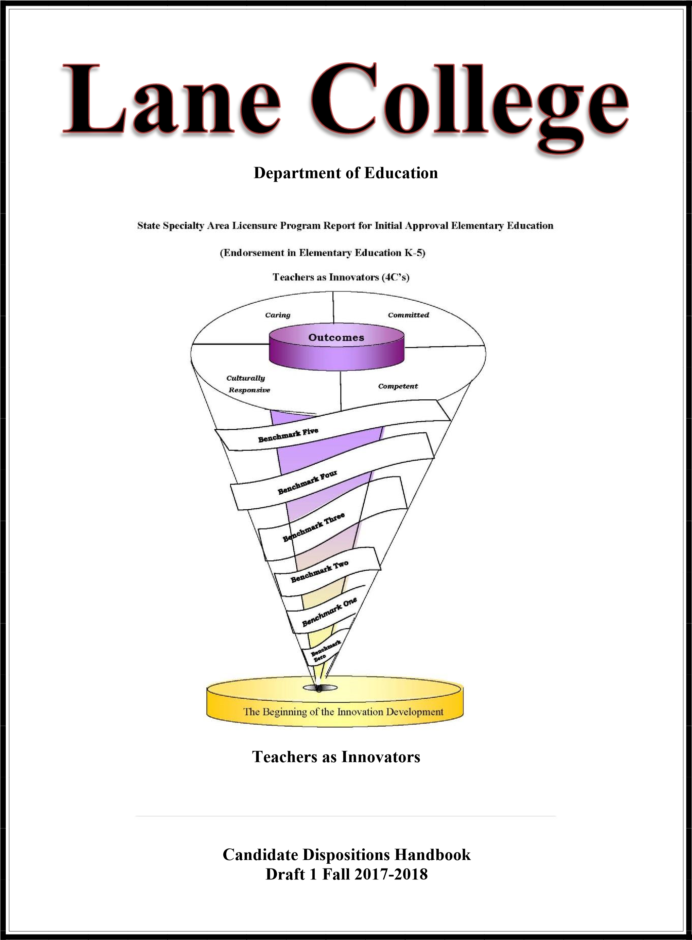

Table of Content

Mission and Vision Statement 3
DOE Conceptual Framework 4
Procedures for Comprehensive and Systematic Assessment of Dispositions 5
Disqualification from Teacher Education 8
Disposition Instrument 10
Disposition Infraction Form 11
Disposition Descriptors 12

Candidate’s Signature Page ...........................................................................................................15
Lane College
Department of Education

Mission and Vision Statement
The Department of Education is committed to the preparation of 21st century teachers who understand the complexities of learning and teaching that encompass inclusion, equity, and social justice. This work is enhanced by a liberal studies foundation that encourages breadth of knowledge, interdisciplinary and international perspectives, engaged inquiry, and intellectual curiosity. We strive to prepare teacher candidates to possess the 4 C’s; Caring, Committed, Culturally Responsive, Competent and who possess the deep knowledge in their field of study and work collaboratively to achieve high quality education for all.

The organizing theme of the Department of Education is “teachers as innovators”. We strive to help our candidates build and construct new methods, ideas and strategies for meeting the challenging and diverse needs of today’s students.

Overarching Unit Goals

Unit Operations Goals
- Meet state and national standards for the Unit.
- Ensure the excellence of all licensure programs in the Unit.
- Respond to the needs of the regional and state-wide teaching community.

Unit Program Goals
- Meet the state and national standards relevant to the various programs.
- Meet the Unit Goals for candidates through the various programs.
- Continue to build strong partnerships with stakeholders.
- Unit Candidate Goals
- Candidates demonstrate knowledge of the depth, breadth, and interdisciplinary connections inherent in the specialty area discipline studied.
- Candidates are knowledgeable of subject matter in order to create meaningful learning experiences for all learners.
- Candidates develop skills necessary for self-reflection and uses this reflection to support student learning and development.
- Candidates demonstrate professional dispositions in varied educational settings with regard to a diversity of students and all members of the school community.

DOE Conceptual Framework
A graphic schema was constructed to incorporate the department of education’s Conceptual Framework. The six ribbons in the schema symbolize our benchmarks. Each benchmark provides information regarding how our teacher candidates matriculate through the program. The top of the spiral represents the expectations held by faculty that graduates will be caring, committed, competent and culturally responsive urban educators. The faculty uses the acronym 4C’s to refer to the spiral construction model.

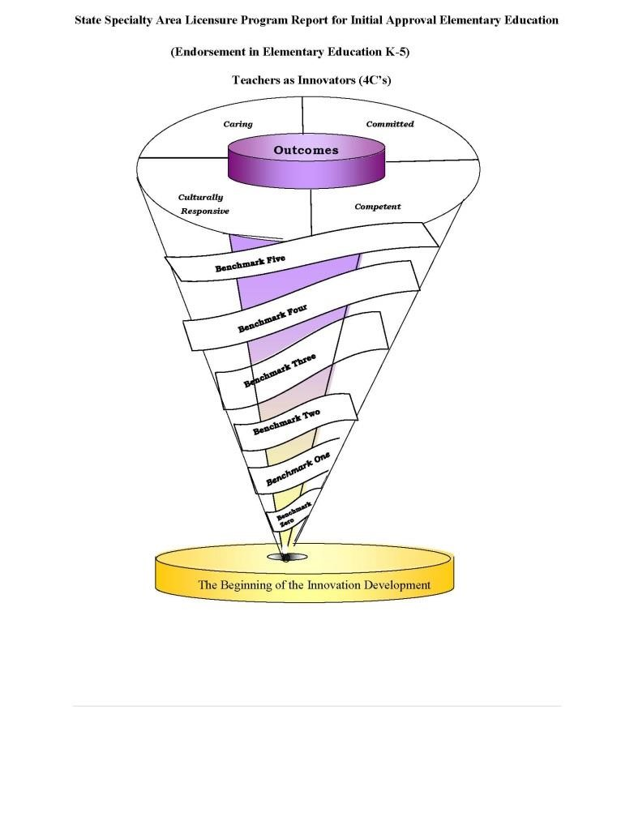

Lane College
Department of Education
Teacher Education Professional Dispositions

Teacher candidates at Lane College are expected to demonstrate a satisfactory level of content area knowledge of which they are expected to teach their students; they must have the pedagogical, professional knowledge and skills to apply effective methods to teacher students who are at different developmental stages, and have different learning styles, and come from diverse backgrounds. Teacher candidates must also demonstrate an understanding of the rights of all students and act on the belief that all children can learn. In addition, teacher candidates must have appropriate dispositions to use their professional knowledge and skills to be effective educators.

Dispositions have been defined as “The habits of professional action and moral commitments that underlie an educator’s performance” (InTASC Model Core Teaching Standards, p. 6CAEP). Dispositions can also be described as attitudes and beliefs about teaching and learning (e.g., fairness and the belief that all students can learn) and as professional conduct and behavior. Not all dispositions can be directly assessed, most aspects of professional behavior are assessed during classes and field experiences in school settings. Professional dispositions of caring are described below.

A caring educator (dispositions)
-understands the right of all students and acts on the belief that all children can learn;
-demonstrates appropriate behaviors during class settings and in the work environment. The candidate has consistently been alert and responsive;
-demonstrates respect for the profession;
-demonstrates punctuality with regard to arrival to class, practicum, student teaching, field experiences, meetings, etc.
-maintains confidentiality;
-demonstrates the ability to compromise and to respect others’ opinions during group work; -participates in professional development activities that were recommended

Multiple CAEP standards address the importance of dispositions and each institution that prepares teachers has an obligation to develop specific criteria and procedures for evaluating this dimension of beginning teacher competence. More importantly, it is necessary to send candidates into field placement knowing that they will exhibit the requisite behaviors.

Therefore, Lane College Department of Education has developed a plan to inform candidates of the requisite dispositions and professional behaviors identified in the InTASC standards, the
CAEP standards, and the College’s Conceptual Framework. These measures will assist the College in identifying problems early and also assist the college in taking actions regarding developing important teacher dispositions. To accomplish this, the following instrument and procedures have been developed.

The Department of Education has adopted the following procedures for the comprehensive evaluation of dispositions for its teacher candidates throughout their programs of study. All teacher candidates will be evaluated for continuous growth and development of dispositions. The disposition evaluation procedures will assist faculty in ensuring fairness for each candidate. Teacher candidates will understand what is expected of them, how they will be scored, the consequences of poor dispositions, as well as the requirements for satisfactory completion of program.

Procedures for Comprehensive and Systematic Assessment of Dispositions Candidates
enrolled in the Teacher Education program are introduced to the Teacher Education Dispositions during orientation. In addition, information regarding dispositions will be articulated in specific classes as well as classes operating with a field-based/practicum/internship component in a school setting. Candidates will be assessed on dispositions at different assessment points prior to completing the program. Candidates will be assessed on admission to the Teacher Education Program (Benchmark I). Candidates will additionally be required to indicate by their signature that they have read and understand the disposition outcomes and policies.

Who does the assessment? Each candidate will complete a self-assessment. The course instructor and/or field mentor teacher will each complete a separate assessment of the candidate. The candidate and instructor may discuss observations of behavior in coursework, field work, and the candidate identified disposition development goals.

When and where is a candidate assessed? Each candidate will be reviewed for dispositional growth and development throughout their participation in the EPP. Formal documentation of assessments will occur a minimum of four times. The table below shows the course number in which a documented assessment will occur. Faculty may choose to use the assessment at other appropriate times.

 |  | Initial Program Elementary K-5
B(0) | B(1) | B(2) | B(3) | B(4) | B(4) | Where  do I  Submit
Entry into College | Admission | Field Experience | Clinical Practices  Before Admission  During Course  After Course | Completion of program | Followup
N/A | Admission’s Application  EDU 230 | EDU 232  EDU 334  EDU 333  EDU 337  EDU 338 | EDU 420  EDU430 | N/A | N/A | Instructor,  Portfolio,  LCAS  System

*The table also shows where the signed assessment form should submitted. Once signed, keep a copy for on-going reflection throughout your program. Each semester, in addition to the course-based assessment, the Disposition Committee will review all completed assessments to determine whether there has been growth demonstrated over time. Any concerns will be addressed by this committee.

What else should a teacher candidate know? It is the candidate’s responsibility to ask clarifying questions as well as demonstrate the expected dispositional behaviors. REMEMBER: Only those dispositions observed in the college classroom or field practicum can be measured, therefore it is up to the candidate to demonstrate these dispositions in all settings.

Candidate Understanding of Dispositional Expectations
Each candidate applying for admission to the Teacher Education Program will sign a disposition verification form indicating that they understand the dispositions that they are to demonstrate in all course work, field/clinical experiences and other activities associated with their becoming a licensed teacher or other support personnel. This form will be turned in to the Admissions Committee Chair and become part of her/his professional education file.

Faculty Reporting of Dispositional Deficiencies
Faculty will submit to both the chair of their department and the Admissions Committee documentation (i.e. Disposition Infraction Form) of any candidate’s lack of proficiency about targeted dispositions. Prior to submitting the documentation, the faculty member must meet with the candidate, discuss the candidate’s deficiency(s), and obtain a signature from the candidate. The signature does not mean that the student agrees with the decision of the faculty member; rather it is just an indicator that the candidate was informed. Before forwarding to the chair and Admissions Committee, the faculty member will summarize the conference with the candidate. Please note: if the deficiency is at a field/clinical site, then both the mentor teacher and college faculty mentor should meet with the candidate to discuss the candidate’s deficiency(s) and follow the same procedure outlined above.

Retention Procedures: Candidates who have a dispositional deficiency reported will be required to meet with the Admissions Committee. The end result could be a recommendation from the Admissions Committee to allow the candidate to continue, the development of a required remediation plan and/or recommendation for dismissal from the program.

In cases of academic dishonesty (cheating and plagiarism), the candidate will follow appeal procedures as outlined in the Student Handbook. The Admissions Committee, following notification of the decision of the Grievance and Appeals Committee about the candidate’s appeal will make a decision about disqualification from the teacher preparation program.

At the meeting, the candidate will be provided an opportunity to explain her/his position and provide the committee any additional relevant information concerning the candidate’s performance in the program.

The committee will make a determination about the candidate’s continuance in the program. The committee may prescribe a remediation plan in conjunction with area faculty or recommend disqualification from the program. The committee’s remediation plan or disqualification recommendation must be submitted within seven (7) working days.

A meeting will be held with the candidate to clarify the action of the committee and have the candidate sign the remediation plan or disqualification recommendation as evidence that the candidate was informed. The candidate’s signature does not indicate agreement with the committee’s decision.

The candidate may appeal the committee’s decision by scheduling a meeting with the Director of Education or Department Chair within 14 days. Prior to this meeting all documentation will be provided to the Dean’s office so that a final determination may be made to either support the committee’s decision or rule in favor of the candidate, whereby the candidate will not have to complete the remediation plan and/or may be readmitted to her/his program.

Disqualification from Teacher Education Program
The Department of Education’s desire to prepare highly qualified professional educators who exemplify the professional ethics and behaviors as discussed in the section on dispositions has led to the identification of some actions on the part of candidates that will result in disqualification from the program. They include:
- Failure to earn a minimum grade of “B” when repeating a professional education related course or course in major.
- Failure to earn a satisfactory grade in a methods course when repeating the course for an unsatisfactory grade.
- Failure to earn a satisfactory grade in two or more education related courses or courses in major.
- Professional/academic misconduct or dishonesty (i. e., cheating, plagiarism, inappropriate behavior in clinical settings, and submitting work products of someone else for a grade).
- Falsification of an academic or assessment record.
- Field/Clinical practice that results in a field/clinical site mentor or administrator recommending removal because of misconduct or inability to demonstrate the necessary knowledge/skill to teach children or youth.
- Field Experience/Clinical Experience while under the influence of alcohol or an illegal substance.
- Background check reveals either a felony or misdemeanor conviction.
- Name appears on State Registry for Sex Offenders.
- Failure to complete recommended counseling or complete successfully the remediation plan prescribed by the College Admission and Retention Committee.

Directions for completing evaluation form:

Candidate teachers:

Conclude whether or not they are struggling, emerging or on-target with the dispositional behaviors.
- Mark the appropriate column. Compare your growth each time you complete a selfassessment.
- Provide two copies of the completed document for review by course instructor.
- If your self-assessment differs from faculty assessment, you may be asked to meet with the instructor.
- Both parties will sign the documents. The instructor will deliver one copy to the Office of Field Experience and Clinical Practice. The other copy is retained by the candidate.

College faculty/ Clinical Practice supervisor

  - Complete the evaluation form at the start and end of core courses as provided on the 2nd page.
  - Complete the evaluation form at the end of clinical practice.
  - Share the information on the form with the candidate teacher.
  - Sign and date the form and have the candidate teacher also sign the form.

Mentor Teacher

  - Complete the form at the end of the clinical practice placement in your class.
  - Share the information on the form with the candidate teacher.
  - Sign and date the form and have the candidate teacher also sign your form.

Disposition Instrument
_______________ _______ | ______________________________ _______
Candidate’s Signature Date | Instructor/Field Supervisor’s Signature Date

Candidate Name ____________________________________
The Disposition of CARING…
… involves caring about and caring for. It is caring about others that moves an individual toward caring for others. When a teacher candidate cares about education and access for all, the candidate is moved to stand in solidarity with, and thus care for others. Care is viewed as a matter of relationships among diverse people (e.g., ability, age, ethnicity, gender, language, sexuality, socio-economic status) rather than as an inherent virtue of an individual.
 | Struggling |  |  | Emerging |  |  | On-Target
understands the rights of all students and acts on the belief that all children can learn.  Instructor/Field Supervisor Comments:  Candidate Comments: | B 1 | B 2 | B 3 | B 1 | B 2 | B 3 | B 1 | B 2 | B 3
demonstrates by appropriate behaviors during class settings and in work environment; The candidate has consistently been alert and responsive.
Instructor/Field Supervisor Comments:

Candidate Comments:
demonstrates a respect for the profession.
Instructor/Field Supervisor Comments:

Candidate Comments:

demonstrates punctuality with regard to arrival to class, practicum, student teaching, field experience, and meetings, etc
Instructor/Field Supervisor Comments:
Candidate Comments:
maintains confidentiality
Instructor/Field Supervisor Comments:
Candidate Comments:

demonstrates the ability to compromise and to respect others’ opinions during group work Instructor/Field Supervisor Comments:
Candidate Comments:
participates in professional development activities that were recommended.

Instructor/Field Supervisor Comments:

Candidate Comments:

Disposition Infraction Form

Candidate name: _________________________________ Date: ____________________

Course number or Incident:
__________________________________________________________________
 | Disposition Infraction  Teacher Candidate DOES NOT: | Check  all that apply | Explain incident in detail
1. | Understands the rights all students and acts on the belief that all children can learn.
2. | Demonstrates by appropriate behaviors during class settings and in work environment: the candidates has consistently been alert and responsive
3. | Demonstrate a respect for the profession
4. | Demonstrate punctuality with regard to arrival to class, practicum, student teaching field experiences and meetings, etc.
5. | Maintain confidentiality
6. | Demonstrates the ability to compromise and to respect others’ opinions during group work
7. | Participates in professional development activities that were recommended
- Only one (1) disposition infraction form may be given per day.
- After having received 2 Disposition Infraction Forms (i.e., Foundation Course, Field and Content Based Courses), a Disposition Committee will meet with you and decide on your status in the Program.
- College Supervisor, Instructor and/or Clinical Instructor should review with candidate prior to signing.
- Signature indicates that candidate has reviewed and received a copy of the form does not necessarily indicate agreement.

Signature of Professor/Instructor: _____________________ Date _____________________ Signature of Teacher Education Candidate: _____________ Date _____________________

Disposition Descriptors
 | Struggling | Emerging | On-Target
Understands the rights of all students and acts on the belief that all child can learn | Occasionally:  -demonstrate behaviors that support a culturally diverse educational environment that provides  opportunities for all students to learn;  - listen attentively to others in a variety of contexts -acknowledges perspectives of individuals from diverse cultural and experiential backgrounds -interacts appropriately in relation to cultural norms  -appreciates and embraces individual differences -demonstrates positive attitudes toward diverse cultures and learners  -conveys high expectations for achievement for all students | Most of the time:  -demonstrate behaviors that support a culturally diverse educational environment that provides  opportunities for all students to learn;  - listen attentively to others in a variety of contexts -acknowledges perspectives of individuals from diverse cultural and experiential backgrounds -interacts appropriately in relation to cultural norms  -appreciates and embraces individual differences -demonstrates positive attitudes toward diverse cultures and learners  -conveys high expectations for achievement for all students | Always:  -demonstrate behaviors that support a culturally diverse educational environment that provides  opportunities for all students to learn;  - listen attentively to others in a variety of contexts -acknowledges perspectives of individuals from diverse cultural and experiential backgrounds -interacts appropriately in relation to cultural norms  -appreciates and embraces individual differences -demonstrates positive attitudes toward diverse cultures and learners  -conveys high expectations for achievement for all students
Demonstrates by appropriate behaviors during class settings and in work environment; The candidate has been alert and responsive | Occasionally receptive to feedback, constructive criticism, and supervision, but fails to implement suggestions.  Occasionally participates in activities and demonstrates energy and enthusiasm. | Receptive to feedback, constructive criticism, and supervision, and attempts to implement suggestions most of the time. Participates in activities most of the time and demonstrates a high level of energy and enthusiasm most of the time. | Always receptive to feedback, constructive criticism, and supervision and adjusts behaviors appropriately. Always participates in activities and demonstrates a high level of energy and enthusiasm.
Demonstrates a respect for the profession | Occasionally:  -displays a respect for the profession (e.g., neat and clean in appearance, appropriate attire for the context/situation, appropriate overall demeanor, prepared for assigned tasks, social sites on the Internet are private or have no offensive material, etc.).  -pays thorough attention to all details including writing mechanics, content, and reflection as appropriate.  -uses appropriate verbal and non-verbal language when communicating. | Most of the time:  -displays a respect for the profession (e.g., neat and clean in appearance, appropriate attire for the context/situation, appropriate overall demeanor, prepared for assigned tasks, social sites on the Internet are private or have no offensive material, etc.).  -pays thorough attention to all details including writing mechanics, content, and reflection as appropriate.  -uses appropriate verbal and non-verbal language when communicating. | Always:  -displays a respect for the profession (e.g., neat and clean in appearance, appropriate attire for the context/situation, appropriate overall demeanor, prepared for assigned tasks, social sites on the Internet are private or have no offensive material, etc.).  -pays thorough attention to all details including writing mechanics, content, and reflection as appropriate.  -uses appropriate verbal and non-verbal language when communicating.
Demonstrates punctuality with regard to arrival to class, practicum, student teaching, field experience, meetings and etc. | Absences beyond the excused absence policy and/or occasionally late. Contacts instructor after absence. | Absences are in line with the excused absence policy. (i.e. Contacts instructor prior to absence, rarely late). | No absences. No late arrivals.
Maintains confidentiality | Occasionally maintains confidentiality of records; participates in gossip about students, school employees, other teacher candidates; does not respect confidentiality of school correspondence/conversation | Maintains confidentiality of student records and of professional correspondence and conversations, most of the time; refrains from gossiping, most of the time. | Always maintains confidentiality of student records and of professional correspondence and conversations, and does not tolerate gossiping or abuses of confidentiality by others.
12
Dispositon Handbook

 | Struggling | Emerging | On-Target
Demonstrates the ability to compromise and to respect others’ opinions during group work | Basic collaboration skills. Occasional difficulty interacting and accepting others ideas. Occasionally disrespectful/insensitive toward individuals. Occasional instances of negative remarks, sarcasm, ridicule toward individuals. | Proficient collaboration skills. Usually an active team member (i.e. shares ideas, considers ideas of the group).  Almost always respectful/sensitive toward individuals. | Sets an example for others. Always respectful/sensitive toward individuals.
Participates in professional  development activities that were  recommended | Occasionally participates in professional development activities but fails to implement suggestions. | Participates in professional development activities most of the time and attempts to implement suggestions most of the time. | Always participates in professional development activities and always implements.

13
Dispositon Handbook

Candidate’s Signature Page (Office Copy)

As an educator, you are to demonstrate intellectual, social, and ethical attributes indicative of the dispositions that contribute to the learning and development of all learners in P-12 settings.
Dispositions refer to those “professional attitudes, values, and beliefs demonstrated through both verbal and non-verbal behaviors as educators interact with students, families, colleagues, and communities.” The dispositions listed below are to be demonstrated through coursework, teaching practicum, professional activities, and student teaching throughout your program of study.

A caring educator (dispositions)
-understands the right of all students and acts on the belief that all children can learn;
-demonstrates appropriate behaviors during class settings and in the work environment. The candidate has consistently been alert and responsive; -demonstrates respect for the profession;
-demonstrates punctuality with regard to arrival to class, practicum, student teaching, field experiences, meetings, etc.
-maintains confidentiality;
-demonstrates the ability to compromise and to respect others’ opinions during group work; -participates in professional development activities that were recommended

I have received, read and I understand the Teacher Education Professional Dispositions and the
implementation procedures.

Teacher Candidate’s Name________________________ T Number _________________

Classification____________________________________

14
Dispositon Handbook

Candidate’s Signature Page (Student Copy)

As an educator, you are to demonstrate intellectual, social, and ethical attributes indicative of the dispositions that contribute to the learning and development of all learners in P-12 settings. Dispositions refer to “The habits of professional action and moral commitments that underlie an educator’s performance” (InTASC Model Core Teaching Standards, p. 6-CAEP). The dispositions listed below are to be demonstrated through coursework, teaching practicum, professional activities, and student teaching throughout your program of study.

A caring educator (dispositions)
-understands the right of all students and acts on the belief that all children can learn;
-demonstrates appropriate behaviors during class settings and in the work environment. The candidate has consistently been alert and responsive; -demonstrates respect for the profession;
-demonstrates punctuality with regard to arrival to class, practicum, student teaching, field experiences, meetings, etc.
-maintains confidentiality;
-demonstrates the ability to compromise and to respect others’ opinions during group work; -participates in professional development activities that were recommended

I have received, read and I understand the Teacher Education Professional Dispositions and the
implementation procedures.

Teacher Candidate’s Name________________________ T Number _________________

Classification____________________________________

15
Dispositon Handbook

